How do different concentration and charge density of impurities affect the voltage produced by a voltaic cell?

**Introduction**

As an aspiring Electrical and Electronics engineering student I have always been fascinated by the implementation of electronics in research capacities and daily lives. In my daily science reading I came across this academic article which described 5 microns thick robots consisting of silicon photovoltaics and electrochemical actuators. It used the photovoltaics to power itself. This puzzled me as my personal knowledge had informed me that as solar cells may be a better alternative to photovoltaics as they are cheaper and have a higher energy yield in comparison. Fascinated by this I wished to learn about what made photovoltaics the choice of energy source in this project.

Photovoltaic cells absorb photons from light and generate a flow of electrons which are swept into an electric field of a certain direction directly allowing the flow of current in the external circuit. In contrast in a solar cell after the absorption of photons of light and the energized electrons must jump an energy barrier to align themselves with the electric field which several electrons may not be able to cross due to not having enough energy. Since current refers to the rate of flow of charges and voltaic cells have a higher electron density in said electric field, they can generate more current as more electrons pass through a point in the external circuit per second in comparison to a solar cell.

After understanding the difference between the working of a voltaic cell in comparison to a solar cell I wanted to understand the role different factors could play with the performance of a voltaic cell. I was more curious regarding how electrolyte composition could improve or degrade the voltaic cell. Hence, I decided to choose my independent variable to be different solutions of varying anions and concentration to be added to a voltaic cell and see how this affects a voltaic cell. Hence, I decided my topic to be the effect of impurities on voltage produced by voltaic cells.

**Research Question:** How do different concentration and charge density of impurities affect the voltage produced by a voltaic cell?

**Background Information**

*Voltaic Cells*

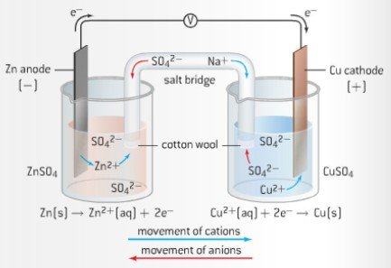 Voltaic Cells convert energy from spontaneous, exothermic chemical reaction to electrical energy. It consists of two separate half cells connected via a salt bridge. In a voltaic cell oxidation occurs at the anode, which is negatively charged, and reduction occurs at the cathode which is positively charged. Refer to figure on the side for diagrammatic representation: -

The salt bridge contains a concentrated solution of a strong electrolyte such as Potassium Sulfate or Sodium Sulfate. The salt bridge which connects both the half cells has three main functions: -

* Provides a physical separation between the oxidation and reduction processes
* Providing electrical continuity for the flow of cations and anions
* Reduces the liquid-junction potential. This is the voltage generated when two different solutions come into contact.

Reaction at the anode: -

Zn(s) ⟶ Zn2+(aq) + 2e-

Reaction at the cathode: -

Cu2+(aq) + 2e- ⟶ Cu(s)

Therefore, the overall reaction is: -

Zn(s) ⟶ Zn2+(aq) + 2e-

Cu2+(aq) + 2e- ⟶ Cu(s)

      Zn(s) + Cu2+(aq) ⟶ Cu(s) + Zn2+(aq)

Voltage or potential difference produced in a cell refers to the electrical force that drives an electric current between two points. Voltage is measures through a cells’ potential difference which can be calculated using the equation below: -

EӨ = EӨcathode - EӨanode

The potential difference produced by the above mentioned voltaic cell is:-

|  |  |  |
| --- | --- | --- |
| Electrode | Half Reactions | EӨ (V) |
| Anode | Zn(s) ⟶ Zn2+(aq) + 2e- | * 0.76[1] |
| Cathode | Cu2+(aq) + 2e- ⟶ Cu(s) | * 0.34[2] |
|  | EӨ(V) | 0.34 - ( - 0.76) = + 1.10 |

*Ionic Mobility*

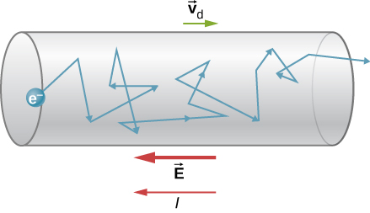Drift velocity refers to the average velocity attained by a charged particle (eg. electrons) obtained due to an electric field[3].Subatomic particles like electrons move in a random direction. When they are subjected to an electric field then they slowly drift in the opposite direction of the electric field applied. The net velocity of these electrons drift in known as drift velocity.

Electric field strength at a point in the electric field refers to the force per unit area acting on a small point positive charge acting at that point. Ionic mobility *‘u’* is defined as the relationship between the drift velocity *‘s’* of the ion attained during electrolysis and the strength of the applied electric field *‘E’*.

*u=s/E*

The ionic mobility can be calculated from the drift velocity *‘s’* of the ion during electrolysis if the strength of the electric field *‘E’* is known. This results from the applied voltage *‘U’* divided by the electrode separation *‘l’*. Electrode separation refers to the distance between electrodes in a voltaic cell to prevent short circuits while allowing transport ions during the passage of current in a voltaic cell.

*E=U/l*

A force *‘F’* acts upon an ion in this electric field which accelerates it in the direction of the oppositely charged electrode. This force results from the product of the electric field strength *‘E’* and the charge on the ion *‘z・e’*.

*F = z・e・E*

Opposing this force is a frictional force *‘FR’* which slows the ion down. This is proportional to its speed .

*FR  = f・s*

Based on the assumption that ions behave like spherical bodies in water, the proportionality factor *‘f’* can be calculated using Stokes' equation. The factor is dependent upon the viscosity *‘η’* of the solvent and the radius *‘ɑ’* of the ion.

*f = 6・π・η・ɑ*

This results in:

*FR = 6・π・η・ɑ・s*

When both of these forces are equal, the ion is no longer accelerated, but moves at a constant velocity towards the oppositely charged electrode. The velocity at which this occurs is termed the drift velocity. The following applies to this:

*F= FR*

*z・e・E = 6・π・η・ɑ・s*

*(z・e)/(6・π・η・ɑ)= s / E = U*

*Born Solvation Model*

The Born Model describes the electrostatic component of Gibbs-Free energy of solvation an ion in a solution. This model treats the solvent as a dielectric medium[4].

*N = Avogadro constant*

*z = charge of ion*

*e = elementary charge*

$ϵ$*= permittivity of free space(vacuum)*

*r = radius of ion*

$ϵ_{r}=$*dielectric constant of solvent*

*Activity theory of ions*

Activity of an ions refers to the effective concentration of the ions that is available to participate in a chemical reaction[5]. The Activity Theory ions gives accurate value for the activity of an ion in a dilute salt solution. This theory is based on the electrostatic model of ions.

When two charges *q1* and *q2* are in a continuous medium[6] The Coulomb's force exerted by q*1* on *q2* is given by: -

$$F=\frac{k \left|q1\right| \left|q2\right|}{r^{2}}$$

Where *‘k’* is the proportionality constant and *‘r’* is the distance between the charges. If the charges have the same sign, the charges repel, and the force exerted maximizes the distance between these two charges.

The activity theory models the environment around a central ion whose activity is to be determined. There are two assumptions: -

1. Interactions between the central ions and other ions are due to Coulomb's forces
2. The central ion is a solid sphere with a radius *‘bc’ and* charge *‘qc’*

This allows us to develop a coordinate system where the origin is represented by the central ion and as the central ions moves in solution so does its coordinate system. This allows us to draw a link between the activity coefficient of the central ion and the electrical work done when the central ion is bought from infinite distance (potential energy = 0) to maximum potential energy.

The theory models the interactions of the central ion with type of ions *‘x’* in the solution using a spherically symmetrical function *‘px(r)’* which specifies the concentration of *‘x’*-type of ions at specified at the location specified by *‘r’*, for *r ≥ bc*. This is when the mobile point-charge model is replaced with a model where charge is consistently distributed.

The visual picture corresponds to this new assumption such that the central ion is discrete while all other ions are grouped up into tiny, charged groups which distributed smoothly-but not uniformly-throughout the solution that surrounds the central ion. This is done as in the mobile point-charge model’s effects will be inaccurate as it would be obtained by summing up a lot of terms whose positions are not well defined. The group of charged species around the central ion can be called its ionic atmosphere.

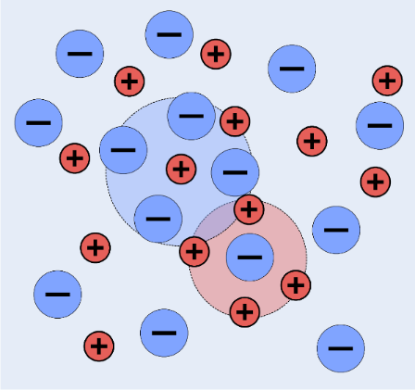The Activity Theory makes these ideas quantitative by finding the work done to create this ionic atmosphere. To do so we must define ionic strength: -

$$I=\sum_{x=1 }^{n}{{{(z}^{2}}_{x} m_{x})/2}$$

Where the sum of all the mass times the square of the charge of the particles are divided by two to make the ionic strength of 1:1 electrolyte equal to its molality.

For a hypothetical 1 molal standard-state the activity coefficient of a solute *X,⋎*c, is related to the chemical potential of the real substance *μc(P,mc)* and that of the hypothetical ideal solute *C* at the same concentration  *μc(Hyp Solute,P,mc)* by:-

$$ln(⋎_{c})=\frac{ μ_{c}(P,m_{c})- μ_{c}(Hyp Solute,P,m_{c})}{RT}$$

The previously mentioned model equates this to chemical potential difference to the electric work that accompanies the introduction of central ion into a solution with ionic *I*. This gives: -

$$ln(⋎_{c}) = \frac{-{z^{2}}_{c} {e^{2}}_{x }N}{8 πε_{o} D (1+ xb_{c})}$$

**Hypothesis:** As charge density and concentration of impurities increase the voltage produced decreases as more energy is required to form the ionic environment around the Zn2+ and Cu2+ ions, which reduces the ionic mobility of these two ions hence reducing the effective concentration of Zn2+ and Cu2+ ions available at the electrodes.

**Variables**

Table 1: Variables

|  |  |  |
| --- | --- | --- |
| **Type of Variable** | **Description of Variables** | **Method of controlling/measuring variable** |
| Independent | Anion in the impurity solution | Solutions of Potassium Nitrate, Potassium Bromide, Potassium Chloride and Potassium Phosphate were prepared. |
| Independent | Concentration of impurity used | Solutions of Potassium Nitrate, Potassium Bromide, Potassium Chloride and Potassium Phosphate of concentrations 0.1 mol/dm3, 0.2 mol/dm3,0.3 mol/dm3,0.4 mol/dm3 and 0.5 mol/dm3. |
| Dependent | The Voltage being produced by two electrodes | The voltage produced by the voltaic cell can be measured by using a multimeter set at voltage mode. |
| Controlled | Concentration of Potassium Sulfate used in the Salt Bridge | 1 mol/dm3 solution of Potassium Sulfate is prepared to soak filter paper in. |
| Controlled | Material for Cathode and Anode | Copper was used for cathode and Zinc was used for anode. Same copper electrode was used in each trial and was rinsed using deionized water and dried with filter papers after subsequent trials. Zinc electrode was changed for each trial. |
| Controlled | Concentration of solution used in each half cell | A stock of 0.1 mol/dm3 of Zinc Sulfate and Copper Sulfate was prepared to be utilized as half-cell solutions. |
| Controlled | Surface area of electrode submerged in electrolyte | Submerge the electrode equally in the electrolyte solutions using stands. |
| Controlled | Temperature | Place thermometers in both half cells and only in conduct experiment when temperature in both half cells is equal |

**Materials**

Table 4: Chemicals

|  |  |
| --- | --- |
| **Chemical** | **Quantity (g)** |
| Potassium Sulfate | 174.26 |
| Zinc Sulfate | 16.15 |
| Copper Sulfate | 15.96 |
| Deionized water | - |
| Potassium Nitrate | 37.644 |
| Potassium Bromide | 44.625 |
| Potassium Chloride | 28.011 |
| Potassium Phosphate Powder | 79.602 |

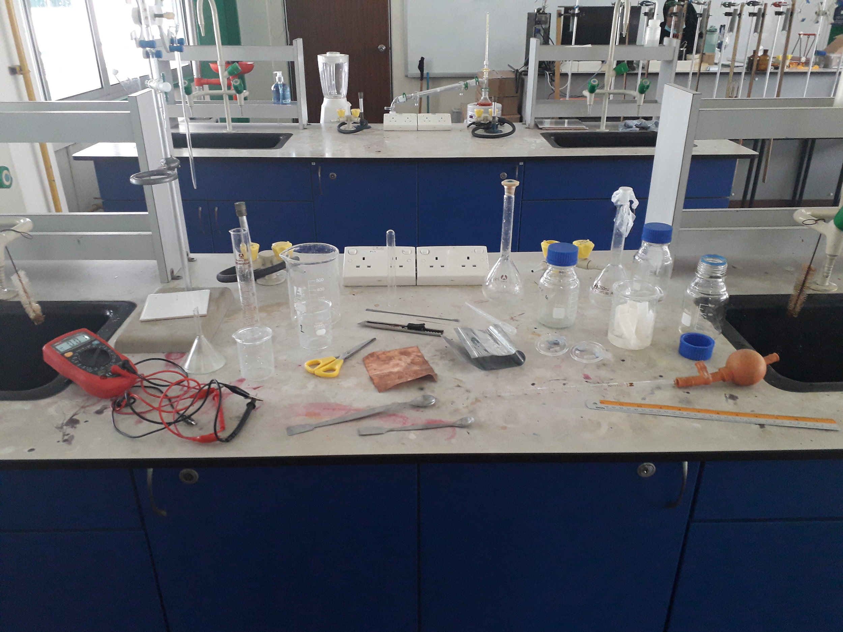

**Database**

Table 2: Anion Charge Density

|  |  |
| --- | --- |
| **Anion** | **Charge Density (C mm-3)** |
| Bromide (Br-) | 6 |
| Chloride (Cl-) | 8 |
| Nitrate (NO32-) | 9 |
| Phosphate (PO43-) | 14 |

The above values are taken from the bcs.freeman[7] and the reason I chose this database as it is linked back to a trusted piece of science literature:[8]Acta Cryst., 1976, A32, 751. This is because it comes a trusted source as well as calculation and estimation method is logically reasoned out.

**Risk Assessment**

Table 4: Safety Precautions

|  |  |
| --- | --- |
| **Safety Precaution** | **Importance** |
| No exposed wires, all insulated | To prevent getting any form of electric shock when handling the wires when handling the wires. |
| Be careful while handling glassware such as beakers | Handle them with extreme care as we are working with metal electrodes which when collide against the walls of the container can result in cracks or breaking of beakers. Ensure when the glassware is not used it is the in-beaker rack or where glassware is supposed to be stored. Broken glass can be a hazard. |
| Wear cut protective gloves while using a knife | Be careful while handling a knife as it can cause cuts on skin. |
| Keep Potassium salts way from eyes. Always wear gloves while handling them. | Potassium salts are mild irritants and can cause redness and mild eye irritation. |

**Methodology**

*1.1: Preparation of Salt Bridge*

1. In a 200 cm3 beaker add 100 cm3 of deionised water
2. On a weighing scale weigh out 7.9 g of potassium sulfate and transfer it to the beaker, stir until fully dissolved.
3. Weigh 4 g of agar-agar and add it to the beaker.
4. Place the beaker onto the electric heater and heat and stir it constantly until it starts bubbling.
5. After it start Bubbling, take a glass u-tube and submerge one of its ends in the solution with the other end blocked using cotton

*1.2: Preparation of Half Cell Solutions*

1. Place a plastic up on the weighing scale and measure out 16.15 g of Zinc Sulfate powder.
2. Using a funnel transfer the zinc sulfate to a 1000 cm3 Volumetric Flask.
3. Add Deionized water until all the zinc sulfate dissolves. Continue adding deionized water until the mark is reached.
4. Repeat steps 1 to 3 in this section with 15.96 g of copper sulfate instead of zinc Sulfate. This is done to prepare 0.1 mol/dm3 of these two solutions

*1.3: Preparation of impurity solutions*

1. Place a plastic cup on the weighing scale and measure out 2.528 g of potassium nitrate.
2. Using a funnel transfer the potassium nitrate in a 250 cm3 Volumetric Flask.
3. Add deionized water until potassium nitrate is dissolved. Continue adding deionized water until mark is made.
4. Prepare other salt impurities using the same procedure as mention through step 1 to 3 for the following masses: -

*Table 5: Masses of Potassium Nitrate, Potassium Chloride, Potassium Bromide and Potassium Phosphate*

|  |  |  |  |  |  |
| --- | --- | --- | --- | --- | --- |
| Concentration (± 0.004 mol/dm3) | 0.1 | 0.2 | 0.3 | 0.4 | 0.5 |
| Mass of Potassium Nitrate added (g) | 2.53 | 5.06 | 7.58 | 10.11 | 12.64 |
| Mass of Potassium Bromide added (g) | 2.98 | 5.95 | 8.93 | 11.90 | 14.88 |
| Mass of Potassium Chloride added (g) | 1.86 | 3.73 | 5.59 | 7.46 | 9.32 |
| Mass of Potassium Phosphate added (g) | 5.31 | 10.61 | 15.92 | 21.23 | 26.53 |

*1.4: Setup of Voltaic Cell and Control Experiment*

1. Place two 100 cm3 beakers next to each other. Using a marker label one as ‘zinc sulfate’ and the other as ‘copper sulfate’.
2. Using a burette transfer 90 cm3 of zinc sulfate Solution into the beaker labeled ‘zinc sulfate. Rinse the burette with deionized water and transfer 90 cm3 of copper sulfate Solution into the other beaker labelled ‘copper sulfate’
3. Using a 10 cm3 pipette add 10 cm3 of deionized water to both beakers.
4. Using a measuring pad, knife and ruler cut out Copper and Zinc Strips of equal length and thickness.
5. Insert the electrodes into the solutions such that it does not touch the sides or bottom of the beaker
6. Attach a multimeter set-in voltage mode to these pieces of electrodes using a crocodile clip
7. Using a thermometer check the temperature of individual half cells
8. When the temperature is observed to be common between the half cells. Take a u-tube and submerge each end into individual beakers. It was ensured they are equally submerged.
9. Repeat this trial 5 times for deionized water
10. Repeat steps 1 to 10 for different concentration of each impurity salt.

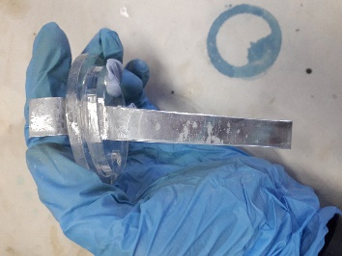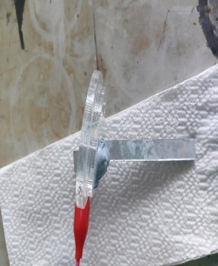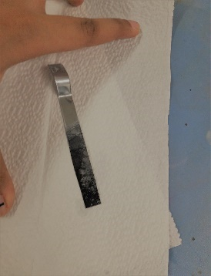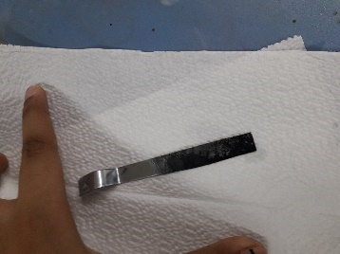

**Analysis**

*Unprocessed Data*

*Table 9: Results for Potassium Bromide, Potassium Chloride, Potassium Nitrate and Potassium Phosphate impurity in voltaic cell*

|  |  |  |  |  |  |  |  |
| --- | --- | --- | --- | --- | --- | --- | --- |
| Impurity Salt | Voltage (V) | Trial 1 | Trail 2 | Trial 3 | Trial 4 | Trial 5 | Standard Deviation |
|  | Concentration(mol/dm3) |  |  |  |  |  |  |
|  | 0 | 1.089 | 1.085 | 1.09 | 1.085 | 1.08 | 0.00396 |
|  | 0.1 | 1.06 | 1.07 | 1.08 | 1.07 | 1.07 | 0.00707 |
| Potassium Bromide | 0.2 | 1.06 | 1.05 | 1.06 | 1.06 | 1.07 | 0.00707 |
|  | 0.3 | 1.05 | 1.045 | 1.05 | 1.05 | 1.05 | 0.00224 |
|  | 0.4 | 1.05 | 1.04 | 1.04 | 1.04 | 1.03 | 0.00701 |
|  | 0.5 | 1.03 | 1.03 | 1.03 | 1.03 | 1.03 | 0 |
|  | 0 | 1.089 | 1.085 | 1.09 | 1.085 | 1.08 | 0.00354 |
|  | 0.1 | 1.08 | 1.08 | 1.07 | 1.08 | 1.075 | 0.004 |
|  | 0.2 | 1.049 | 1.05 | 1.05 | 1.05 | 1.05 | 0.0004 |
| Potassium Chloride | 0.3 | 1.03 | 1.03 | 1.03 | 1.035 | 1.029 | 0.00214 |
|  | 0.4 | 1.02 | 1.03 | 1.029 | 1.027 | 1.03 | 0.00376 |
|  | 0.5 | 1.03 | 1.01 | 1.02 | 1.01 | 1.01 | 0.008 |
|  | 0 | 1.089 | 1.085 | 1.09 | 1.085 | 1.08 | 0.00396 |
|  | 0.1 | 0.96 | 0.96 | 0.96 | 0.96 | 0.96 | 0 |
| Potassium Nitrate | 0.2 | 0.94 | 0.94 | 0.94 | 0.94 | 0.95 | 0.00447 |
|  | 0.3 | 0.93 | 0.94 | 0.92 | 0.94 | 0.93 | 0.00837 |
|  | 0.4 | 0.91 | 0.92 | 0.92 | 0.91 | 0.91 | 0.00548 |
|  | 0.5 | 0.91 | 0.9 | 0.9 | 0.89 | 0.89 | 0.00837 |
|  | 0 | 1.089 | 1.085 | 1.09 | 1.085 | 1.08 | 0.00396 |
|  | 0.1 | 0.85 | 0.84 | 0.73 | 0.85 | 0.86 | 0.05413 |
| Potassium Phosphate | 0.2 | 0.72 | 0.76 | 0.69 | 0.71 | 0.76 | 0.03114 |
|  | 0.3 | 0.62 | 0.64 | 0.65 | 0.65 | 0.66 | 0.01517 |
|  | 0.4 | 0.55 | 0.58 | 0.58 | 0.58 | 0.61 | 0.02121 |
|  | 0.5 | 0.47 | 0.5 | 0.49 | 0.47 | 0.51 | 0.01789 |

*Processed Data*

*Table 11: Results for Potassium bromide, Potassium Chloride, Potassium Phosphate and Potassium Nitrate*

|  |  |  |  |  |  |  |
| --- | --- | --- | --- | --- | --- | --- |
| Impurity Salt | Average Concentration (mol/dm3) | Absolute Uncertainty (±) | Percentage Uncertainty (%) | Average Voltage (V) | Absolute Uncertainty  (±) | Percentage Uncertainty  (%) |
|  | 0.000 | 0.004 | ± 0.04 | 1.09 | 0.0005 | ± 0.05 |
|  | 0.100 | 0.004 | ± 0.04 | 1.07 | 0.0005 | ± 0.05 |
| Potassium Bromide | 0.200 | 0.004 | ± 0.04 | 1.06 | 0.0005 | ± 0.05 |
|  | 0.300 | 0.004 | ± 0.04 | 1.05 | 0.0005 | ± 0.05 |
|  | 0.400 | 0.004 | ± 0.04 | 1.04 | 0.0005 | ± 0.05 |
|  | 0.500 | 0.004 | ± 0.04 | 1.03 | 0.0005 | ± 0.05 |
|  | 0.000 | 0.004 | ± 0.04 | 1.09 | 0.0005 | ± 0.05 |
|  | 0.100 | 0.004 | ± 0.04 | 1.08 | 0.0005 | ± 0.05 |
|  | 0.200 | 0.004 | ± 0.04 | 1.05 | 0.0005 | ± 0.05 |
| Potassium Chloride | 0.300 | 0.004 | ± 0.04 | 1.030 | 0.0005 | ± 0.05 |
|  | 0.400 | 0.004 | ± 0.04 | 1.027 | 0.0005 | ± 0.05 |
|  | 0.500 | 0.004 | ± 0.04 | 1.02 | 0.0005 | ± 0.05 |
|  | 0.000 | 0.004 | ± 0.04 | 1.09 | 0.0005 | ± 0.05 |
|  | 0.100 | 0.004 | ± 0.04 | 0.96 | 0.0005 | ± 0.05 |
| Potassium Nitrate | 0.200 | 0.004 | ± 0.04 | 0.94 | 0.0005 | ± 0.05 |
|  | 0.300 | 0.004 | ± 0.04 | 0.93 | 0.0005 | ± 0.05 |
|  | 0.400 | 0.004 | ± 0.04 | 0.91 | 0.0005 | ± 0.05 |
|  | 0.500 | 0.004 | ± 0.04 | 0.90 | 0.0005 | ± 0.05 |
|  | 0.000 | 0.004 | ± 0.04 | 1.09 | 0.0005 | ± 0.05 |
|  | 0.100 | 0.004 | ± 0.04 | 0.826 | 0.0005 | ± 0.05 |
| Potassium Phosphate | 0.200 | 0.004 | ± 0.04 | 0.782 | 0.0005 | ± 0.05 |
|  | 0.300 | 0.004 | ± 0.04 | 0.644 | 0.0005 | ± 0.05 |
|  | 0.400 | 0.004 | ± 0.04 | 0.580 | 0.0005 | ± 0.05 |
|  | 0.500 | 0.004 | ± 0.04 | 0.488 | 0.0005 | ± 0.05 |

Sample Calculation

Mass of KNO3 taken = 2.258 ± 0.0005 g

Mr of KNO3 = 101.1032

$moles=\frac{mass}{Mr }$ = $\frac{2.258}{101.32}$ =0.02500

$\% uncertainty=\frac{0.0005}{2.258}$* 100% = 0.019778 %

Volume = 0.25 ± 0.00005 dm3

Concentration = == 0.100 mol/dm3

% Uncertainty = 0.019778 + 0.02 = 0.0397785 %

Absolute Uncertainty = 0.100 * 0.0397785 = 0.004

Graphs: -

*Graph1: Voltage produced by Copper-Zinc Voltaic Cell containing different concentration of potassium bromide impurity*

*Graph2: Voltage produced by Copper-Zinc Voltaic Cell containing different concentration of potassium chloride impurity*

*Graph3: Voltage produced by Copper-Zinc Voltaic Cell containing different concentration of potassium nitrate impurity*

*Graph4: Voltage produced by Copper-Zinc Voltaic Cell containing different concentration of potassium phosphate impurity*

*Graph 5: Voltage produced by Copper-Zinc Voltaic Cell containing different concentration of different impurities*

Qualitative Analysis

As the charge density of the anion on the impurity and concentration increased the thickness of a bluish-grey coating on the Zinc electrode decreased as there is less effective concentration of ions available at the electrodes to do electrical work at the electrodes.

**Evaluation**

|  |  |  |
| --- | --- | --- |
| **Source of Error** | **Effect on experiment** | **Scope of Improvement** |
| Unevenly cut Electrodes | Larger electrodes increase current generated while reducing total internal resistance of circuit. | Use a machine cutter to cut the electrode pieces more accurately. This was not available in the lab and hence could not be done. |
| Constant Temperature | There is radiation of heat from the surroundings which can affect voltage readings. | Use two water baths set at constant temperature for both half cells to maintain constant temperature. |

**Analysis**

My results concur with my hypothesis. As anionic charge density and concentration of impurities increases the voltage produced decreases linearly. As the charge density of the anion’s increases more energy is required to solvation of these impurity solutions in the dielectric solution of Zinc and Copper Sulfate. This energy spent by the central ion such as Zn2+

to create an ionic atmosphere, reduce the total free energy available for Zn2+ to travel to the electrode. This causes lesser number of Zn2+ ions in the solution to reach the electrode, reducing their effective concentration at the electrode. This in turn causes lesser Zn2+ ions to dissociate, reducing its ionic mobility, hence reducing the voltage produced as well making the coating on the zinc electrode to decrease. As concentration increases there are more anions from the impurity solution per unit area, higher number of ions need to be solvated in the electrolyte. More energy needs be spent from the central ion to solvate the more anions causing the free energy left with the central ion Zn2+ to further decrease and hence causing ionic mobility to decrease and voltage decreases.

**Conclusion**

The voltage produced by a Copper-Voltaic Cell in the presence of no impurities was found to be 1.0858 ± 0.0005. This value is in general agreement with the literature value of a Copper Zinc Voltaic Cell. The literature value of 1.10 V was used to calculate the experiment’s percentage error.

$Percentage error=\left|\frac{experimental value-theoretical value}{theoretical value}\right|$* 100%= $\left|\frac{1.0858-1.10}{1.10}\right|$* 100%= 1.29 %

$Random error=\frac{5(0.05)}{5}$*= 0.05 %*

*Systematic Error = Percentage Error - Random Error= 1.29% - 0.05% = 1.24 %*

I have high confidence in results due to the low systematic error which indicate a higher degree of accuracy in my exploration. This combined with the low standard deviations and variance amongst replicates and low total error of the experiment shows high precision in my results further make my results reliable. Furthermore, my experiment agrees with the current scientific consensus, such as that as anionic charge density and concentration of impurities increases the voltage produced by a voltaic cell decreases which is substantiated by my observation of the blueish grey coating on the Zinc Electrode decreasing at higher concentrations and anionic charge densities of impurities. The strong negative correlation is again emphasized by the high *R2* value across each impurity (R2=0.9914,0.9501,0.7416 and 0.9407) indicating that an extremely high percentage the changes in the voltage (dependent variable) is caused by change in anionic charge density and concentration of impurities (independent variables).

To conclude, the results show that as concentration and anionic charge density of impurity solutions in voltaic cells increase voltage produced decreases which in turn would negatively affect the performance of the electrochemical actuators and photovoltaics in the nano-robots. Thus, this investigation emphasizes the importance of purity of fuels to increase power efficiency and yield per unit fuel.

**Scope of Further Investigation**

A possible extension for this investigation would be to deduce the effect of organic impurities on the voltage produced by a voltaic cell. Another extension of this topic is to see the effect of magnetism and transition metal complex impurities on the voltage produced by voltaic cells.

**Bibliography**

1. [The Effect of Impurities and Other Factors on the Current Density in Electro-chemical Reactors](http://sphinxsai.com/s_v2_n2/CT_V.2No.2/ChemTech_Vol_2No.2_pdf/CT=85%20(1289-1300).pdf)
2. <https://www.ld-didactic.de/documents/en-US/EXP/C/C4/C4412_e.pdf>
3. <http://www.umich.edu/~chem260/fall01/lecture36.pdf>
4. <https://www.powerstream.com/internal-resistance.htm>
5. <https://ui.adsabs.harvard.edu/abs/1979JChEd..56..576J/abstract>
6. <http://www.wiredchemist.com/chemistry/data/thermochemical-radii-anions>
7. [https://vdocuments.site/chemistry-voltaic-cell-ia.htcm](https://vdocuments.site/chemistry-voltaic-cell-ia.html)
8. <https://gbutler.edublogs.org/files/2015/12/Experimental-Uncertainty-of-Apparatus-Worksheet-Solutions-1bcr61w.pdf>
9. <https://s3.amazonaws.com/warneronline-assets/s3fs-public/2018-09/agar_bridges.pdf>
10. <https://www.wolframalpha.com/input/?i=nitrate+ionic+radius>

**Appendix A**

**Apparatus**

Table 3: Apparatus

|  |  |  |
| --- | --- | --- |
| **Apparatus** | **Quantity** | **Uncertainty** |
| Multimeter | х1 | ±0.05V |
| Funnel | х1 | - |
| 250 cm3 Volumetric Flask | х1 | ± 0.05 cm3 |
| 500 cm3 Beaker | х1 | ± 5 cm3 |
| Burette | х1 | ± 0.5 cm3 |
| 100 cm3 Beaker | х2 | ± 0.5 cm3 |
| 10 cm3 Pipette | х1 | ± 0.05 cm3 |
| Pipette Bulb | х1 | - |
| U-Tube | - | - |
| Copper Sheet | х1 | - |
| Zinc Sheet | х1 | - |
| Knife | х1 | - |
| Metal Ruler | х1 | - |
| Weighing Scale | х1 | ± 0.0005 g |
| Measuring Pad | х1 | - |
| Dropper | х2 | - |
| Magnetic stirrer | х1 | - |
| Spatula | х2 | - |
| Thermometer | х2 | ± 0.005 |

1. IB Chemistry Data Booklet,Section 24 : https://www.ibchem.com/root_pdf/data_booklet_2016.pdf
2. IB Chemistry Data Booklet,Section 24 : https://www.ibchem.com/root_pdf/data_booklet_2016.pdf
3. https://byjus.com/physics/drift-velocity/
4. https://www.thefreedictionary.com/Dielectric+medium#:~:text=General%20Physics)%20a%20substance%20or,the%20properties%20of%20a%20dielectric
5. https://chem.libretexts.org/Bookshelves/Physical_and_Theoretical_Chemistry_Textbook_Maps/Supplemental_Modules_(Physical_and_Theoretical_Chemistry)/Physical_Properties_of_Matter/Solutions_and_Mixtures/Nonideal_Solutions/Activities_and_their_Effects_on_Equilibria#:~:text=In%20chemical%20thermodynamics%2C%20activity%20(symbol,concentration%20for%20an%20ideal%20solution.
6. http://www.ipgp.fr/~kaminski/web_doudoud/Malvern_book.pdf
7. https://bcs.whfreeman.com/WebPub/Chemistry/raynercanham6e/Appendices/Rayner-Canham%205e%20Appendix%202%20-%20Charge%20Densities%20of%20Selected%20Ions.pdf
8. https://scripts.iucr.org/cgi-bin/paper?a12967